YEAR 6 – Library offerings with MISS BUTLER / MISS BRITTANY

- CURSIVE
- SPELLING – Qualify students for the Spelling Bee and TESTS
- ABC order as a necessary skill
- TYPING (for accuracy and speed)
- STORYTELLING – reading aloud and BUDDY READERS (with elementary school in the district and each other)
INCENTIVES:
Each teacher will be given two library passes a piece to use as a REWARD (going to the library is not a punishment or a negative visit)
***Please call me if you are sending a student down to the library***
THEY CAN:
- Come in to read/check out a book and have a break (UP TO 15 minutes)
- FRIENDSHIP BRACELETS (a la Taylor Swift – if you know you know)
- Harry Potter activities – MAJOR LEGO ACTIVITY, engaging crafts, subject specific activities, etc.
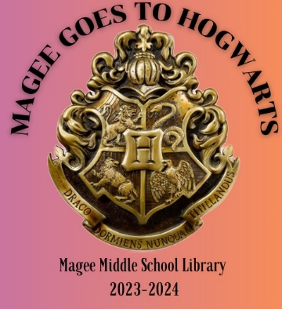

HARRY POTTER HOUSES
EVERYONE HAS BEEN SORTED: Here’s the breakdown…
ADMIN and FRONT OFFICE: Slytherin
6th Grade team: RAVENCLAW
7th Grade team: HUFFLEPUFF
8th Grade team: GRYFFINDOR
ALL ELECTIVES, TA’s, SPECIAL ED, etc., can choose their house.

STUDENTS WILL BE ABLE TO EARN POINTS…
- Doing service/being a good citizen on campus
- HOW MANY DAYS WITHOUT INCIDENT (by grade and will be announced on Friday announcements)
- Anything else you as staff believe they should earn HOUSE POINTS for, give a point value and send me your total by the end of the week with the house that has earned those points.
- At a certain point, a large reward will be given (like at 100 points we will have a popcorn party, etc.)
***In the lobby of the library on the bulletin board, the tally will be kept. ***

